Payroll Management System for Information Technology Company

Use-Case Specification: Delete report

Version 1.0

Revision History

|  |  |  |  |
| --- | --- | --- | --- |
| **Date** | **Version** | **Description** | **Author** |
| 28/12/2019 | 1.0 | Final | Nguyen Khac Phuc |
|  |  |  |  |
|  |  |  |  |
|  |  |  |  |

Table of Contents

1. Delete report 4

1.1 Brief Description 4

2. Flow of Events 4

2.1 Basic Flow 4

2.2 Actor 4

3. Special Requirements 4

3.1 Requirement step. 4

4. Preconditions 5

5. Postconditions 5

6. Extension Points 5

Use-Case Specification: Delete report

# Delete report

## Brief Description

This use-case defines the step of delete a report. Admin can easily delete a post by find a post with its id and then hit the delete button.

# Flow of Events

## Basic Flow

* Users log in with the admin account. Admin clicks manage salary button, then enter the id of the post. After that, admin clicks search button, the information of the post will appear on the view then clicks the delete button to delete the post.

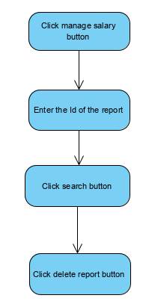

## Actor

-Administrator

# Special Requirements

## Requirement step.

-Id of the report must be filled before click delete button.

# Preconditions

* User must log in into the system with the admin account

# Postconditions

* Show message if delete report success, the system will show message successfully or else the system will show message failed

# Extension Points